# Calculating binomial probabilities

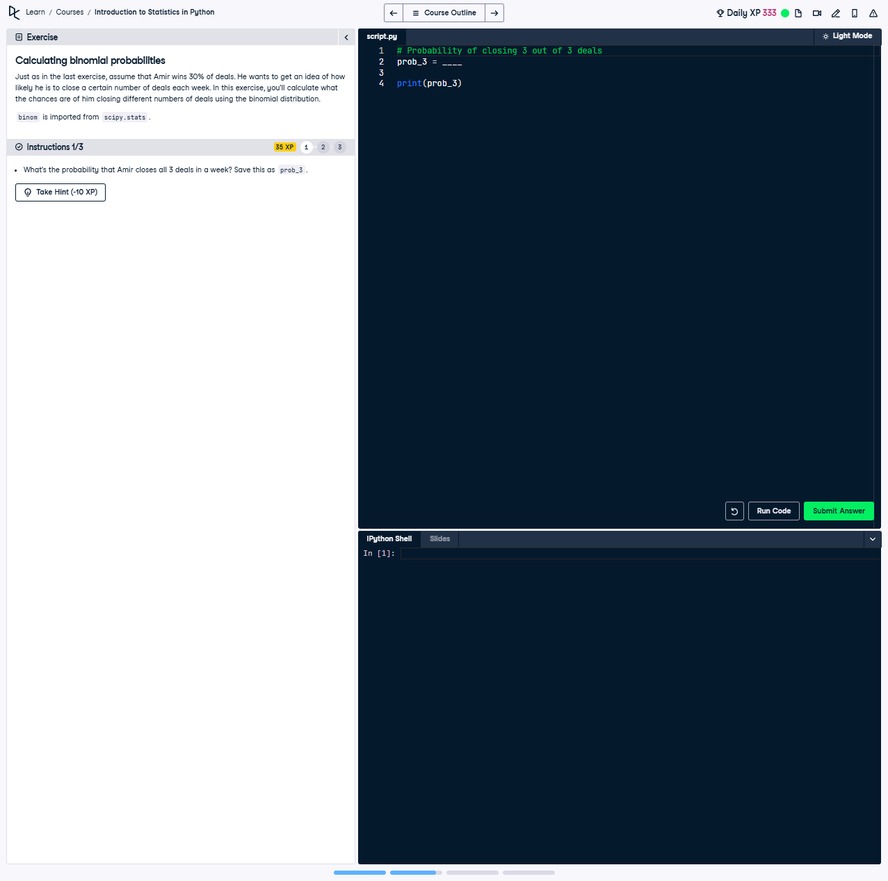

## Question:

What's the probability that Amir closes all 3 deals in a week? Save this as prob_3.

## Explanation of the Question:

This question asks us to calculate the probability of a successful outcome in all 3 attempts given a 30% success rate, using the binomial probability formula.

## Answer:

from scipy.stats import binom  
  
# Calculate the probability of closing 3 out of 3 deals with a success probability of 0.3  
prob_3 = binom.pmf(3, 3, 0.3)  
  
print(prob_3)

## Explanation of the Answer:

The solution uses the binom.pmf function from scipy.stats to compute the probability mass function (PMF) of the binomial distribution. Here, 3 is the number of successes, 3 is the total number of trials, and 0.3 is the probability of success. The result is stored in prob_3 and printed.